

AI ChatBot

UCSI INTERNSHIP PROGRAM

1. PROJECT OVERVIEW



This project aims to develop a **Python- based AI Chatbot system** within **two weeks (40 total hours)** to supporting queries ranging from admission, programmes, and faculty information to academic records, results, and campus life services.



## AI ChatBot

UCSI INTERNSHIP PROGRAM





본 프로젝트는 **2주(총 40시간)** 내에 **Python 기반 AI 챗봇 시스템**을 개발하여, **입학, 학과 및 학부 정보부터 학적, 성적, 그리고 캠퍼스 생활 관련 서비스에 이르기까지** 다양한 문의를 지원하는 것을 목표로 합니다.

1. PROJECT OVERVIEW

# This project emphasizes:

* 1. Short development cycle (2 weeks/40 hours)
  2. Team-based competition (2 parallel teams)
  3. Integration with UCSI Database
  4. An AI system with basic self-learning and continuous improvement capability

## AI ChatBot

UCSI INTERNSHIP PROGRAM



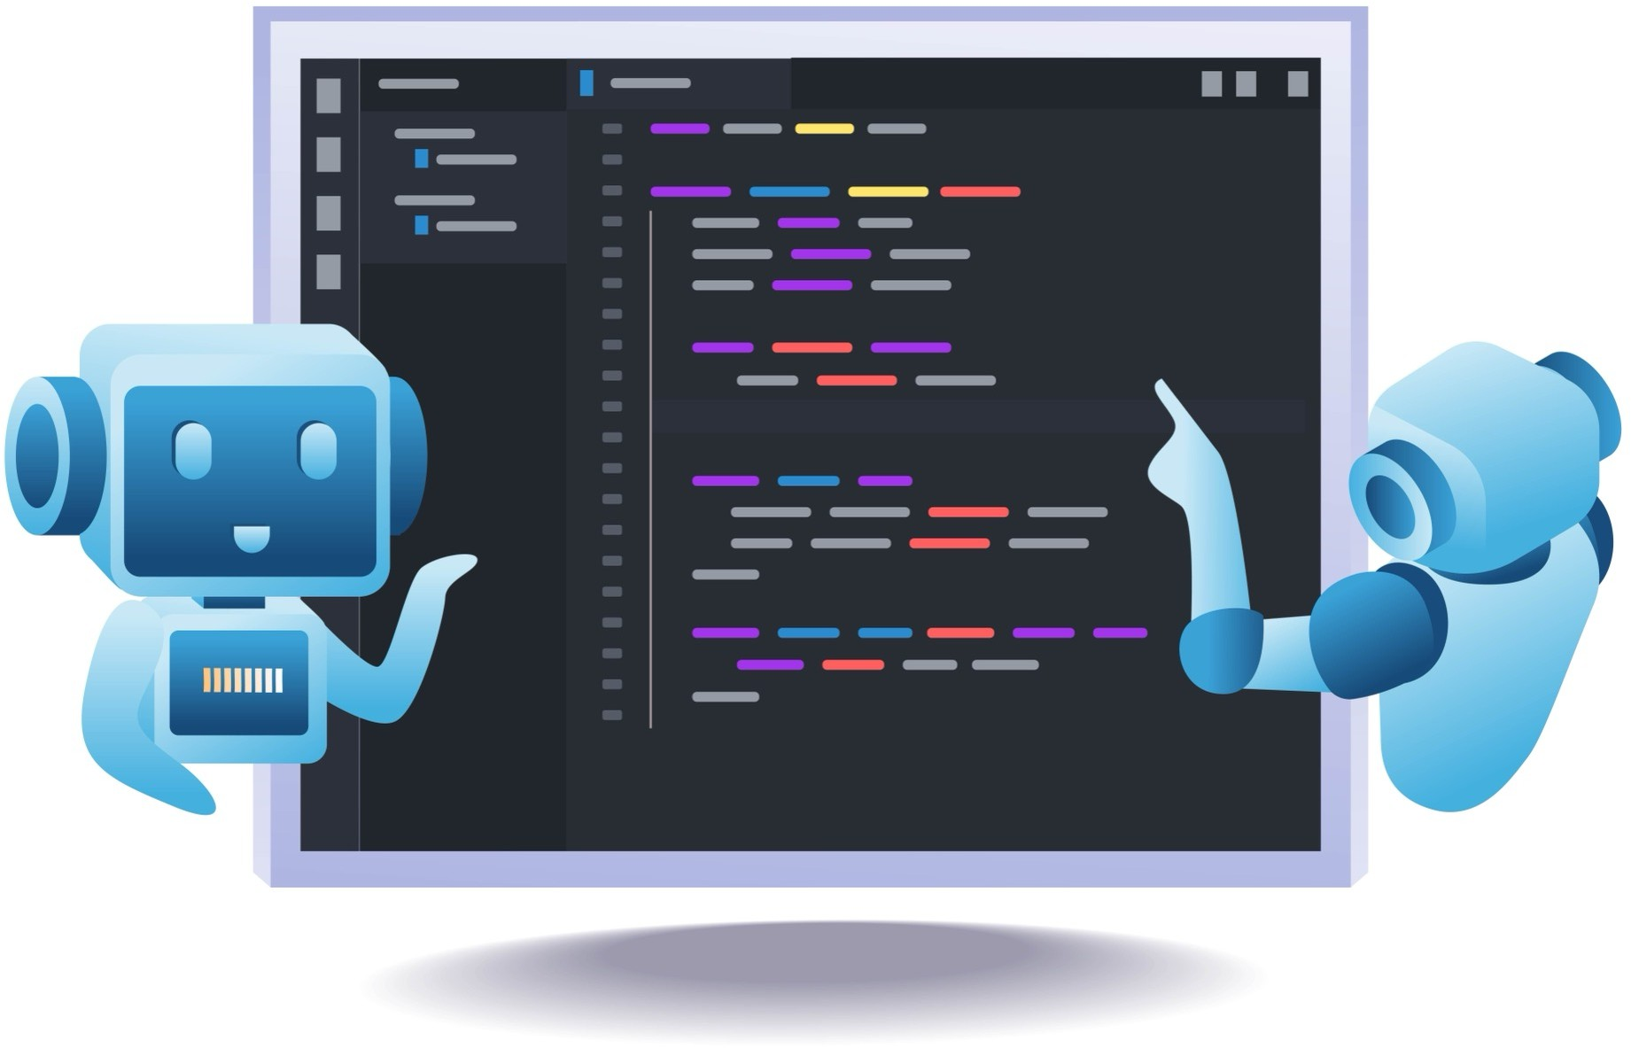**이 프로젝트는 다음 사항을 강조합니다:**

* + 1. 짧은 개발 주기 (2주/40시간)
    2. 팀 기반 경쟁 (2개의 병렬 팀)
    3. UCSI 데이터베이스와의 통합
    4. 기본적인 자기 학습 및 지속적 개선 능력을 갖춘 AI

시스템

1. OVERALL SYSTEM ARCHITECTURE

**HIGH-LEVEL SYSTEM LOGIC**

상위 시스템 논리 흐름

The AI conversation engine handles interpretation and natural language expression, while the business logic layer enforces rules and guarantees factual correctness.

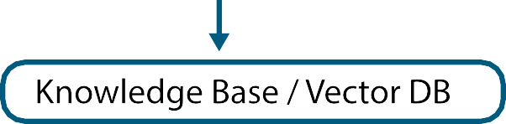

## AI ChatBot

UCSI INTERNSHIP PROGRAM



AI 대화 엔진은 사용자 의도를 이해하고 표현을 생성하며, 비즈니스 로직 계층은 규칙을 적용하고 사실의 정확성을 보장합니다.

1. OVERALL SYSTEM ARCHITECTURE



# RECOMMENDED TECHNOLOGY STACK

**BACKEND**

* + Python 3.10 +
  + FastAPI (API services)
  + JWT / OAuth2 (authentication)

## AI ChatBot

UCSI INTERNSHIP PROGRAM

추천 기술 스택

1. OVERALL SYSTEM ARCHITECTURE

## AI ChatBot

UCSI INTERNSHIP PROGRAM

**RECOMMENDED TECHNOLOGY STACK** 추천 기술 스택



**AI / NLP Module**

* + Large Language Model

(e.g. OpenAI API / local LLM such as LLaMA or Mistral)

* + LangChain (conversation flow & tool orchestration)
  + Vector Database (FAISS / Chroma)
  + Embedding models (text vectorization)

1. OVERALL SYSTEM ARCHITECTURE

## AI ChatBot

UCSI INTERNSHIP PROGRAM

**RECOMMENDED TECHNOLOGY STACK** 추천 기술 스택



**Database**

* + UCSI Database (read-only / controlled access)
  + Vector Database (FAISS / Chroma)

1. FUNCTIONAL MODULES

### Query & Consultation Functions

질의 및 상담 기능

## AI ChatBot

UCSI INTERNSHIP PROGRAM



|  |  |
| --- | --- |
| **General Information Queries (No Authentication Required)** | **Student / Lecturer-Specific Queries (Authentication Required)** |
| UCSI University general information | Student enrollment status |
| Faculty and school introductions | Registered programmes and semester status |
| Programme and course information | Academic results inquiry (Student ID & Password) |
| Campus facilities |  |
| Hostel types, fees, and application guidance |  |

1. FUNCTIONAL MODULES

**CONVERSATIONAL LOGIC FLOW**



대화 논리 흐름

## AI ChatBot

UCSI INTERNSHIP PROGRAM



1. SELF LEARNING CAPABILITY

## AI ChatBot

UCSI INTERNSHIP PROGRAM

### DEFINITION OF SELF-LEARNING (Within Project Scope)



자기 학습 정의 (프로젝트 범위 내)

Within the limited two-week timeframe, self-learning does not imply autonomous intelligence, but rather:

* + **Continuous ingestion of new knowledge**
  + **Improvement of responses based on feedback**
  + **Human-controlled knowledge management mechanisms**

1. SELF LEARNING CAPABILITY

## AI ChatBot

UCSI INTERNSHIP PROGRAM

### DEFINITION OF SELF-LEARNING (Within Project Scope)



자기 학습 메커니즘 구현

# Admin Knowledge Management Panel

* + Upload new documents (PDF / Word / Text)
  + Update program or policy information

4. SELF LEARNING CAPABILITY

## AI ChatBot

UCSI INTERNSHIP PROGRAM

### DEFINITION OF SELF-LEARNING (Within Project Scope)



자기 학습 메커니즘 구현



# Vectorization Pipeline

Vector DB

Documents

Text Chucking

Embeding

1. SELF LEARNING CAPABILITY

## AI ChatBot

UCSI INTERNSHIP PROGRAM

### DEFINITION OF SELF-LEARNING (Within Project Scope)



자기 학습 메커니즘 구현

# Conversation Feedback Learning

* + User satisfaction / dissatisfaction tagging
  + Logging unanswered or low-confidence questions

1. SELF LEARNING CAPABILITY

## AI ChatBot

UCSI INTERNSHIP PROGRAM

### DEFINITION OF SELF-LEARNING (Within Project Scope)



자기 학습 메커니즘 구현

# Hybrid Rule-Based + AI Optimization

* + Convert high-frequency questions into rule-based answers
  + Use AI to handle long-tail or complex queries

1. Team Division & Role Allocation

### Team Formation Principles

팀 구성 원칙

## AI ChatBot

UCSI INTERNSHIP PROGRAM



Team A and Team B have **balanced and comparable skill distributions**



Each team is capable of AI development, system logic, and user experience design

5. Team Division & Role Allocation

**TEAM A COMPOSITION**

## AI ChatBot

UCSI INTERNSHIP PROGRAM



**3**

**Intelligent Media Engineering**

**UI/UX,**

**Chat Experience, Frontend**



A팀 구성

**2**

**AI Engineers**

**NLP,**

**Prompt Design, Embeddings, RAG**



**1**

**Computer Engineer**

**Architecture &**

**Security (Shared)**

5. Team Division & Role Allocation

**TEAM B COMPOSITION**

## AI ChatBot

UCSI INTERNSHIP PROGRAM



**3**

**Intelligent Media Engineering**

**UI/UX,**

**Chat Experience, Frontend**



B팀 구성

**2**

**AI Engineers**

**NLP,**

**Prompt Design, Embeddings, RAG**



**1**

**Intelligent Media Engineering**

**Assist Architecture & Security and**

**Frontend (Share)**

5. WORK SCHEDULE



### Total Time Allocated

총 작업 시간

## AI ChatBot

UCSI INTERNSHIP PROGRAM

5. WORK SCHEDULE

### Week 1 — Core Development

1주차 핵심 개발

## AI ChatBot

UCSI INTERNSHIP PROGRAM

Day 1



Day 2

Day 3

Day 4

Day 5

Project kickoff, architecture design, data field confirmation FastAPI setup, Basic conversation flow, Intent classification design Database connection, Programme & faculty queries, Initial UI prototype

Vector knowledge base implementation

Internal testing

1. WORK SCHEDULE

### Week 2 — Enhancement & Demo

2주차 기능 개선 및 데모

## AI ChatBot

UCSI INTERNSHIP PROGRAM

Day 6



Day 7

Day 8

Day 9

Day 10

Student authentication mechanism, Enrollment & registration status queries Academic results query (access-controlled), security, logging & audit

Self-learning module implementation, Admin knowledge upload panel Bug fixing and optimization, Demo scenario preparation

Final project demonstration, Q&A session

1. Security & Compliance Considerations



보안 및 준수 사항

* + Dual authentication for result enquiries

성적 조회 시 이중 인증

* + Read-only database access

읽기 전용 데이터베이스 접근

* + Log anonymization

로그 익명화

AI ChatBot

UCSI INTERNSHIP PROGRAM

1. FINAL Deliverables



최종 산출물

* + Python AI Chatbot prototype

파이썬 AI 챗봇 프로토타입

* + Admin knowledge feeding system

관리자 지식 투입 시스템

* + Database-integrated demo

DB 연동 데모

* + Live or recorded demonstration

실시간 또는 녹화 데모

* + Technical documentation

기술 문서

AI ChatBot

UCSI INTERNSHIP PROGRAM

7. Project Lead

## AI ChatBot

UCSI INTERNSHIP PROGRAM



Zan

The Manager

Rex Voon

The Supervisor



**Thank You**

**감사합니다**